[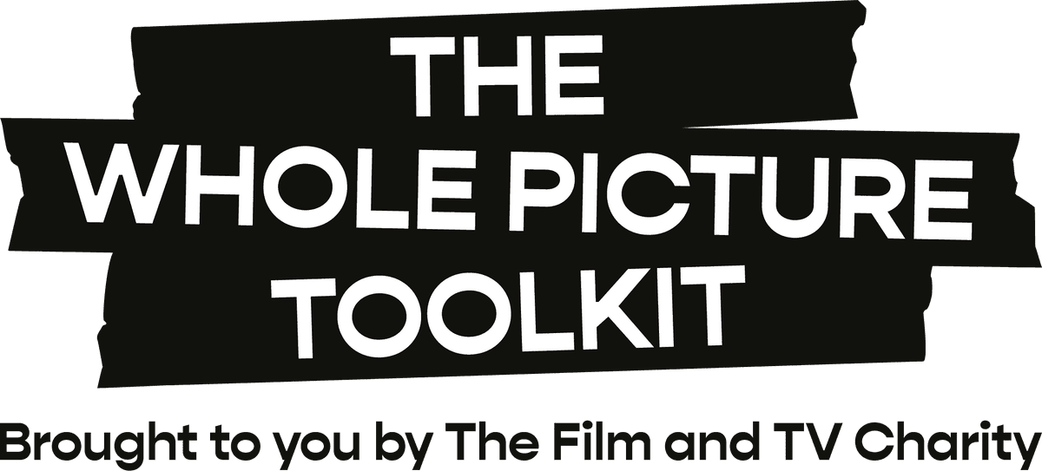](https://wholepicturetoolkit.org.uk/)**Mental Health Stress Risk Assessment: template**

All productions have a legal duty of care to prevent stress and mental health issues in their workers – and to assess the risks.

A mental health stress risk assessment is used to identify potential stressors (hazards) associated with poor mental health, and their risk levels, so an action plan can be created to help prevent stress and burnout.

Complete this template for your production, to identify the issues, the risk levels and decide which [**Toolkit actions**](https://wholepicturetoolkit.org.uk/) can help address them. It’s structured around six Health and Safety Executive Management standards on stress but isn’t comprehensive as stressors are unique to each production.

For guidance on how to complete this template:

* See our Toolkit guide: [**Create a mental health stress risk assessment**](https://wholepicturetoolkit.org.uk/pre-production/create-a-mental-health-risk-assessment/).
* Download our [**example MHSRA**](https://wholepicturetoolkit.org.uk/app/uploads/2025/07/MHSRA-example.docx) to understand typical issues and risk levels in film and TV.
* Use the desktop version of Word (rather than browser) for the best editing experience.
* For any suggestions to improve this template, or any part of the Toolkit, we’d love to [**hear from you**](https://surveys.hotjar.com/25003442-e9a4-4aef-82b5-c0c7ecf9d920).
* © The Film and TV Charity: Guidance in this editable template should not be altered, and all [**Whole Picture Toolkit**](https://wholepicturetoolkit.org.uk/) references, links and images must be retained. For more details on this, please see our **fair use notice** below.

**Using this template**

1. Under each work area, number each issue and describe the hazard. (Be aware of including personal data, and comply with GDPR rules).
2. Classify each issue by risk level, as: red **A**, amber **B**, or green **C** – based on probability and severity – using the table below.
3. Determine any control measures that should be taken, to mitigate risk levels, by outlining specific actions.
4. Classify each risk level if the actions were to be completed.
5. Allocate any roles or responsibilities, and a date for completion.
6. Routinely review your risk assessment, and the risk levels following the completion of actions.

|  |  |  |
| --- | --- | --- |
| **Risk classification levels** | | |
| **A** | Significant risk | Situation is dangerous or unsafe. Stop the activity! |
| **B** | Moderate risk | Activity can continue, providing controlling factors are reliable. |
| **C** | Insignificant risk | No action necessary. |

**Add: [Production name] [Completed by] [Date]**

**Work area 1: Demands**   
  
Includes risk areas such as:

* Workload
* Work patterns
* The work environment

|  |  |  |  |  |  |  |
| --- | --- | --- | --- | --- | --- | --- |
| Issue number | Hazard identified | Risk level – no controls | Proposed control measures and actions | Risk level – with controls | Person responsible | Date completed |
|  |  |  |  |  |  |  |
|  |  |  |  |  |  |  |
|  |  |  |  |  |  |  |
|  |  |  |  |  |  |  |

**Work area 2: Relationships**

Includes risk areas such as:

* Bullying and harassment
* Conflict
* Management style

|  |  |  |  |  |  |  |
| --- | --- | --- | --- | --- | --- | --- |
| Issue number | Hazard identified | Risk level – no controls | Proposed control measures and actions | Risk level – with controls | Person responsible | Date completed |
|  |  |  |  |  |  |  |
|  |  |  |  |  |  |  |
|  |  |  |  |  |  |  |
|  |  |  |  |  |  |  |

**Work area 3: Support**

Includes risk areas such as:

* Encouragement
* Sponsorship
* Resources provided by the industry, production, line management and colleagues

|  |  |  |  |  |  |  |
| --- | --- | --- | --- | --- | --- | --- |
| Issue number | Hazard identified | Risk level – no controls | Proposed control measures and actions | Risk level – with controls | Person responsible | Date completed |
|  |  |  |  |  |  |  |
|  |  |  |  |  |  |  |
|  |  |  |  |  |  |  |
|  |  |  |  |  |  |  |

**Work area 4: Role:**

Includes risk area:

* Does the crew understand their role on the production and how they are being supported?

|  |  |  |  |  |  |  |
| --- | --- | --- | --- | --- | --- | --- |
| Issue number | Hazard identified | Risk level – no controls | Proposed control measures and actions | Risk level – with controls | Person responsible | Date completed |
|  |  |  |  |  |  |  |
|  |  |  |  |  |  |  |
|  |  |  |  |  |  |  |
|  |  |  |  |  |  |  |

**Work area 5: Control**

Includes risk area:

* How much control the crew have in the way they do their work?

|  |  |  |  |  |  |  |
| --- | --- | --- | --- | --- | --- | --- |
| Issue number | Hazard identified | Risk level – no controls | Proposed control measures and actions | Risk level – with controls | Person responsible | Date completed |
|  |  |  |  |  |  |  |
|  |  |  |  |  |  |  |
|  |  |  |  |  |  |  |
|  |  |  |  |  |  |  |

**Work area 6: Change:**

Includes risk area:

* How organisational change (large or small) is managed and communicated on the production.

|  |  |  |  |  |  |  |
| --- | --- | --- | --- | --- | --- | --- |
| Issue number | Hazard identified | Risk level – no controls | Proposed control measures and actions | Risk level – with controls | Person responsible | Date completed |
|  |  |  |  |  |  |  |
|  |  |  |  |  |  |  |
|  |  |  |  |  |  |  |
|  |  |  |  |  |  |  |

**Copyright and fair use notice**  
© The Film and TV Charity  
  
Guidance in this editable Word template is designed with input from industry, mental health and legal experts, and is reviewed and updated by them and our teams from time to time. The guidance should not be altered.  
  
All [**Whole Picture Toolkit**](https://wholepicturetoolkit.org.uk/) references, links and images must be retained on this template, though we appreciate that production companies may wish to add their own branding as well as the production information that’s relevant to the template’s purpose.    
  
All other Toolkit guidance – that is, non-editable guides – should not be altered in any way.  
  
Templates and guidance can be downloaded and/or printed for distribution.  
  
For more information, see our [**Terms and Conditions**](https://wholepicturetoolkit.org.uk/terms-conditions/).[](https://wholepicturetoolkit.org.uk/)